Campus Event Management System
Complete Application Description
HTML5 CSS3 JavaScript JSP Java Servlets JDBC MySQL Apache Tomcat

Technical project report describing the implemented features, architecture, database, workflows, validation, security, deployment, and testing approach.
Academic Mini Project Documentation

Application Summary
The Campus Event Management System is a role-based, stateful Java web application for publishing campus events, registering student participants, issuing unique event passes, and reporting registration activity. It provides separate interfaces for participants and organizers while maintaining authenticated sessions between login and logout. The application is implemented as a Maven WAR and runs on Apache Tomcat 9.
Participants can create an account only after verifying their email address with an OTP. Organizers are seeded by the system and cannot register from the public form. They authenticate with their organizer ID and password and then complete an email OTP step. Passwords are stored as BCrypt hashes with a cost factor of 12.

Document Scope
This report describes the application as currently implemented. It covers functional requirements, role permissions, pages and endpoints, database tables, validation, security controls, email workflows, setup, testing, limitations, and recommended production improvements.

Contents
- 1 Project Overview
- 2 Users and Role Permissions
- 3 Functional Modules
- 4 End to End Workflows
- 5 Application Architecture
- 6 Database Design
- 7 Validation Rules
- 8 Security and Session Management
- 9 Email and OTP Services
- 10 User Interface Design
- 11 Routes and Servlets
- 12 Installation and Deployment
- 13 Testing and Verification
- 14 Current Limitations
- 15 Future Enhancements
- 16 Conclusion

1 Project Overview

1 1 Purpose
The application replaces manual event announcements, paper registrations, and spreadsheet-based attendance lists with one web portal. Students can discover active events and retain their unique pass information, while organizers can maintain event data and inspect registration records from a protected dashboard.

1 2 Objectives
- Provide secure participant self-registration with email ownership verification.
- Use the student roll number as a unique username for login.
- Keep organizer account creation outside the public registration workflow.
- Support complete event creation, viewing, updating, and deletion by organizers.
- Present available and registered events as clear image cards.
- Issue a unique event pass ID after successful registration.
- Allow organizers to search and filter complete registration reports.
- Maintain server-side session state until the user logs out or the session expires.

1 3 Technology Stack
Layer | Technology | Responsibility
Client | HTML5 CSS3 JavaScript | Forms, responsive layout, field validation, dialogs, and password visibility.
View | JSP | Server-rendered participant, organizer, authentication, event, and report views.
Controller | Java Servlets | HTTP routing, authorization checks, validation, and workflow coordination.
Security | HttpSession AuthFilter BCrypt | Authenticated state, protected routes, roles, and password hashing.
Data access | JDBC AppDao | Prepared statements, schema initialization, queries, and transactions.
Database | MySQL | Persistent users, events, images, profile photos, and registrations.
Email | JavaMail Gmail SMTP | Registration OTP, organizer OTP, and event pass confirmation.
Build and runtime | Maven WAR Tomcat 9 Java 17 | Compilation, packaging, deployment, and servlet execution.

2 Users and Role Permissions
Capability | Participant | Organizer
Create own account | Yes after email OTP | No
Login credential | Roll number and password | Organizer ID and password plus email OTP
View active events | Yes | Yes including inactive events
Register for events | Yes | No
View event pass | Yes for own registrations | Via registration reports
Create edit delete event | No | Yes
View registration members | No | Yes
Search and filter reports | No | Yes
View profile | Own profile | Own account profile

3 Functional Modules

3 1 Authentication Module
The login page accepts a roll number or organizer ID and password. Participant credentials are verified directly. A valid organizer login is held as a pending authentication state until the OTP sent to the organizer email address is verified. The login interface includes a password visibility control and Reset and Login buttons.

3 2 Participant Registration Module
Only participants can use the public registration form. It collects full name, unique roll number, email, phone number, college, department, study year, gender, address, profile photograph, password, and confirmation password. The email must be verified before the Submit button becomes available. Every registration field is mandatory.
The college field uses the ten approved college names, the department field uses CSE, IT, AI&DS, CSM, EEE, ECE, MECH, CIVIL, and ASE, and the year field is limited to 1 through 4. Uniqueness checks protect roll number, email, and phone number.

3 3 Participant Dashboard
- Dashboard cards show counts for currently available events and registered events.
- Available Events shows all open events, including events already registered by the participant.
- Category and department dropdowns filter available events.
- Registered Events shows completed registrations and supports the same filters.
- View opens the full event description and Back returns to the appropriate event section.
- Register now creates the registration; the successful redirect opens Registered Events.
- Already Registered is shown in green and opens participant and pass details in a dialog.
- Profile presents the participant photograph and complete registration information.

3 4 Organizer Dashboard
- Dashboard cards summarize total events, active events, and registrations.
- All Events displays every event and supports category and department filters.
- New Event opens an event form with image upload and mandatory fields.
- Edit and View opens the existing event; Back returns to All Events.
- Delete removes the event and associated registrations after confirmation.
- Members opens registration reports filtered to the selected event.
- Registration Reports supports search plus event, college, department, and year filters.
- Profile displays the organizer account information.

3 5 Event Management Module
Each event contains a title, description, category, department, venue, event date and time, registration closing date and time, capacity, fee, image, organizer, availability status, and registration count. Descriptions appear only on the event details page, keeping the event cards concise. Uploaded event images are stored in MySQL as BLOB data.

3 6 Registration and Pass Module
A participant may register once per event while the event is active, open, and below capacity. The current project records payment as PAID for demonstration. A unique pass ID is stored with the registration and included in the confirmation email. Duplicate registrations are rejected by both application checks and a database unique constraint.

4 End to End Workflows

4 1 New Participant Workflow
1. Open the participant registration page and enter all required information.
2. Request an email OTP and enter the received code.
3. The application displays whether OTP verification succeeded or failed.
4. After successful OTP verification, submit the registration form.
5. The server validates every field and confirms that roll number, email, and phone are unique.
6. The server hashes the password with BCrypt cost 12 and saves the participant profile.
7. Login using the roll number and password to access the participant dashboard.

4 2 Organizer Login Workflow
1. Enter the organizer ID and password on the common login page.
2. After the credentials are validated, an OTP is sent to the organizer email address.
3. Enter the OTP on the verification screen.
4. The authenticated organizer is stored in HttpSession and redirected to the organizer dashboard.

4 3 Event Registration Workflow
1. Browse Available Events and optionally filter by category and department.
2. Use View to inspect the complete event description and return to the events list.
3. Select Register now for an eligible event.
4. The server checks active status, registration deadline, capacity, and duplicate registration.
5. The registration is stored as PAID and assigned a unique pass ID.
6. A professional confirmation email is sent and the browser opens Registered Events.
7. Use Details to view participant data, payment state, registration time, and pass ID.

5 Application Architecture
The system follows a layered Model View Controller style. Browsers submit requests to Servlet endpoints. The AuthFilter protects authenticated routes, controllers coordinate business rules, JSP pages render the response, AppDao performs JDBC operations, and EmailService communicates with Gmail SMTP.
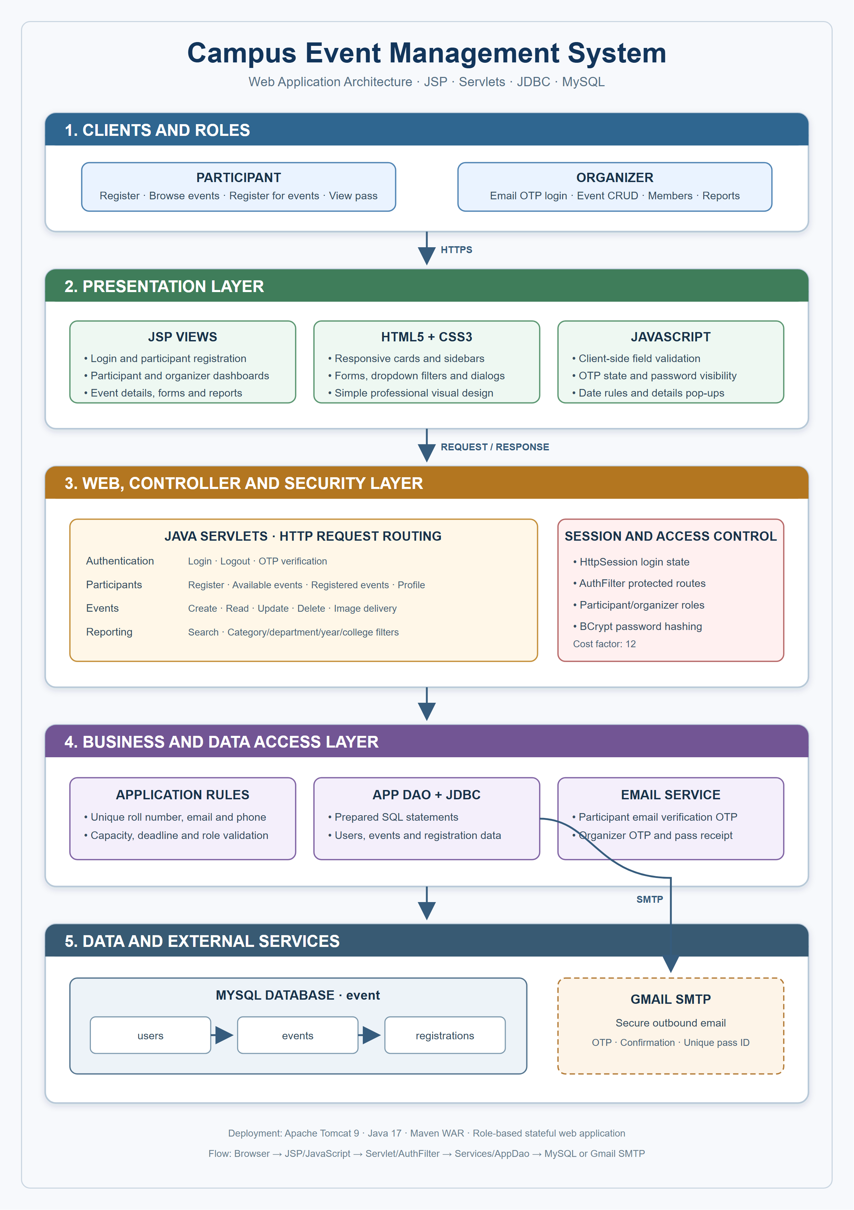
Figure 1 Campus Event Management System architecture

5 1 Request Processing
A request begins in the browser and is sent to a URL mapped to a Servlet. Protected requests pass through AuthFilter. The Servlet reads request parameters and session data, validates the operation, calls AppDao or EmailService, stores any message required by the next screen, and either forwards to a JSP or redirects to a clean endpoint.

5 2 Stateful Session Model
The application is stateful. HttpSession stores the authenticated User object, flash messages, pending organizer authentication, and temporary OTP information. Logout invalidates the session. This enables navigation among protected pages without asking for credentials on every request.

6 Database Design
The application uses the MySQL database named event. AppDao initializes the schema and seeds the first organizer. Foreign keys protect relationships, and uniqueness constraints prevent duplicate identities and duplicate event registrations.

6 1 Users Table
Attribute | Type | Purpose
roll_no | VARCHAR 30 PK | Participant roll number or organizer ID and login username.
full_name | VARCHAR 100 | Display name of the account holder.
email | VARCHAR 150 UNIQUE | Unique account email used for OTP and notifications.
phone_number | VARCHAR 15 UNIQUE | Unique participant contact number.
college_name | VARCHAR 150 | Selected participant college.
password_hash | VARCHAR 255 | BCrypt password hash; plain text is not stored.
role | ENUM | PARTICIPANT or ORGANIZER.
department | VARCHAR 10 | Selected academic department.
study_year | INT | Participant year from 1 through 4.
gender | VARCHAR 20 | Selected participant gender.
address | VARCHAR 500 | Participant address entered in the text area.
profile_photo | MEDIUMBLOB | Uploaded participant profile image.
profile_photo_type | VARCHAR 100 | Stored MIME type for image delivery.
created_at | TIMESTAMP | Account creation time.

6 2 Events Table
Attribute | Type | Purpose
id | INT PK AI | Unique event identifier.
title | VARCHAR 150 | Event name shown on cards and details.
description | TEXT | Complete event description shown after View.
category | VARCHAR 60 | Technical, Cultural, Sports, Workshop, or Seminar.
department | VARCHAR 10 | Department responsible for the event.
venue | VARCHAR 150 | Event location.
event_date | DATETIME | Scheduled event date and start time.
registration_closes_at | DATETIME | Registration deadline before event start.
capacity | INT | Maximum permitted registrations.
fee | DECIMAL 10 2 | Registration fee; zero is allowed.
image_data | MEDIUMBLOB | Uploaded event card image.
image_type | VARCHAR 100 | Stored event image MIME type.
organizer_id | VARCHAR 30 FK | Organizer that owns the event.
active | BOOLEAN | Whether registration is available.
created_at | TIMESTAMP | Event record creation time.

6 3 Registrations Table
Attribute | Type | Purpose
id | INT PK AI | Unique registration record.
event_id | INT FK | Registered event; deletion cascades from events.
participant_id | VARCHAR 30 FK | Participant roll number.
pass_id | VARCHAR 40 UNIQUE | Unique event access pass identifier.
payment_status | ENUM | PAID or PENDING; current demo registration uses PAID.
registered_at | TIMESTAMP | Date and time of registration.
event participant | UNIQUE pair | Prevents one participant registering twice for one event.

6 4 Relationships
- One organizer can create many events through events.organizer_id.
- One participant can register for many events through registrations.participant_id.
- One event can contain many participant registrations through registrations.event_id.
- The registrations table resolves the many-to-many relationship between participants and events.

7 Validation Rules

7 1 Registration Validation
- Every participant field is mandatory, including the uploaded profile photograph.
- Email must be verified by OTP before form submission is enabled.
- Roll number, email address, and phone number must be unique.
- Phone number must follow the accepted ten-digit format.
- Year must be one of 1, 2, 3, or 4.
- College and department must match the approved dropdown values.
- Password must contain 6 to 15 characters with at least one lowercase letter, uppercase letter, number, and special character.
- Password and confirmation password must match.
- Profile photo type and upload size are checked by the server.

7 2 Event Validation
- Title, description, category, department, venue, dates, capacity, fee, and initial image are mandatory.
- Category and department must match the defined values.
- Capacity must be at least one and the fee cannot be negative.
- The registration closing date and time must be earlier than the event start.
- The registration closing date and time must be in the future.
- Uploaded event images are limited to JPG, PNG, or WEBP and a maximum of 5 MB.

7 3 Event Registration Validation
- Only authenticated participants may register.
- The event must exist and be active.
- The deadline must not have passed and capacity must remain available.
- A participant cannot register for the same event twice.

8 Security and Session Management

8 1 Password Security
PasswordUtil applies BCrypt with a cost factor of 12. BCrypt automatically salts hashes, making stored credentials more resistant to precomputed attacks. Login compares the submitted password with the stored hash rather than decrypting a password.

8 2 Authorization
AuthFilter prevents unauthenticated access to protected routes. Individual Servlets also check the User role before participant-only or organizer-only operations. Profile image access is restricted so participants cannot request another participant's image, while organizers retain the access required for administration.

8 3 Session Lifecycle
- A successful login stores the User object in HttpSession.
- Organizer login remains pending until OTP verification succeeds.
- Protected pages reuse the session identity for role checks and personalized content.
- Short-lived OTP values and flash messages are removed after use.
- Logout invalidates the complete session and returns the browser to login.

8 4 Database Safety
JDBC operations use PreparedStatement parameters for user-supplied values, reducing SQL injection risk. Primary keys, foreign keys, and unique indexes enforce important data rules even if multiple requests arrive close together.

9 Email and OTP Services
Message | Recipient | Purpose
Participant registration OTP | Entered participant email | Verify email ownership before account submission.
Organizer login OTP | Stored organizer email | Complete the second authentication step.
Event registration receipt | Participant email | Confirm registration and provide event and unique pass details.

EmailService uses authenticated Gmail SMTP with TLS. Email failures are logged without discarding an event registration that has already been committed. OTP expiration is validated using session timestamps. Production deployments should supply SMTP secrets through protected environment configuration and rotate any classroom credential before publishing source code or a WAR file.

10 User Interface Design
The interface uses a simple professional visual style with no animation. The common top bar presents identity and logout controls. Participant and organizer dashboards use left side navigation on desktop and a responsive layout on smaller screens. Cards present event images and compact metadata, while complete descriptions appear on dedicated detail screens. Dialog elements display registration and pass information without leaving the list.
Screen | Main Elements
Login | Role-aware authentication, username, password visibility, Login, Reset, and registration link.
Registration | OTP verification, participant information, dropdowns, radio buttons, address, photo upload, password controls, Submit, Reset, and Back.
Participant dashboard | Summary cards, sidebar, available cards, registered cards, profile, filters, and pass dialogs.
Organizer dashboard | Summary cards, sidebar, New Event, event filters, event CRUD, reports, and profile.
Event form | Mandatory event fields, date and time rules, image upload, active status, Save, Reset, and Back.
Reports | Search box, dropdown filters, matching count, and complete registration table.

11 Routes and Servlets
Route | Servlet | Purpose
/login | Login | Display login and authenticate credentials.
/verify-otp | OtpServlet | Verify the organizer login OTP.
/logout | LogoutServlet | Invalidate the session.
/register | RegisterServlet | Display and save participant registration.
/registration-email-otp | RegistrationEmailOtpServlet | Send and verify participant email OTP.
/dashboard | DashboardServlet | Display the role-specific summary dashboard.
/events | DashboardServlet | Display filtered participant or organizer event list.
/registrations | DashboardServlet | Display the participant registered-event list.
/profile | DashboardServlet | Display the role-specific profile section.
/event | EventServlet | View details and perform organizer event CRUD.
/event-image | EventImageServlet | Stream an event image from MySQL.
/profile-photo | ProfilePhotoServlet | Stream an authorized profile image.
/registration | RegistrationServlet | Register a participant for an event and send receipt.
/reports | ReportServlet | Display searchable and filterable organizer reports.

12 Installation and Deployment

12 1 Requirements
- Java Development Kit 17 or later
- Apache Maven 3.9 or later
- MySQL 8 or later
- Apache Tomcat 9 because the application uses javax.servlet
- A Gmail account and app password when real email delivery is required

12 2 Configuration
Variable | Purpose
DB_URL | JDBC URL for the event database.
DB_USER | MySQL username.
DB_PASSWORD | MySQL password.
SMTP_HOST | SMTP server, normally smtp.gmail.com.
SMTP_PORT | SMTP submission port, normally 587.
SMTP_USER | Authenticated SMTP account.
SMTP_FROM | Optional From address.
DEFAULT_ORGANIZER_ID | Organizer ID seeded on first initialization.
DEFAULT_ORGANIZER_EMAIL | Organizer email that receives login OTPs.
DEFAULT_ORGANIZER_PASSWORD | Initial organizer password before BCrypt hashing.

12 3 Build and Run
1. Start MySQL and ensure the configured account can create or use the event database.
2. Configure database, organizer, and SMTP values in the Tomcat or Eclipse runtime environment.
3. Run mvn package from the project directory.
4. Deploy target/campus-events.war to Apache Tomcat 9.
5. Start Tomcat and open the deployed campus-events context in a browser.
6. The application listener initializes the tables and default organizer automatically.

13 Testing and Verification
Area | Verification
Build | Maven compiles 22 Java source files and packages the WAR successfully.
Database | users, events, and registrations are created with keys and constraints.
Credentials | Passwords use 60-character BCrypt hashes beginning with the cost 12 marker.
Uniqueness | Repeated roll number, email, or phone produces an already-exists response.
Registration OTP | Submit remains unavailable until the correct email OTP is verified.
Organizer OTP | Organizer session is not authenticated before the second step succeeds.
Event dates | A deadline on or after the event start is rejected.
Event filters | Category and department combinations filter organizer and participant cards.
Event registration | Success opens Registered Events and creates one pass per participant and event.
Reports | Search and dropdown filters narrow complete registration records.
Logout | Session invalidation prevents protected-page access until another login.

13 1 Seeded Demonstration Data
The development database includes a default organizer and may include demonstration participants and events for testing. The ten dummy participants use IDs DUMMY001 through DUMMY010 and the classroom password Password@123, stored only as BCrypt hashes in the database. They are distributed across single and multiple event registrations. These credentials must not be retained in a production deployment.

14 Current Limitations
- Payment is simulated by recording PAID and is not connected to a payment gateway.
- The project uses a single organizer seed workflow and does not provide an administrator account-management console.
- Images are stored directly in MySQL, which is appropriate for a mini project but may not scale as efficiently as object storage.
- The current classroom SMTP configuration must be externalized and rotated before distribution or production use.
- The application does not currently provide event cancellation, participant feedback, or self-service password recovery.
- The WAR is designed for one Tomcat application instance; clustered session storage is not configured.

15 Future Enhancements
- Integrate a payment gateway with signed callbacks and transaction reconciliation.
- Add an administrator role for organizer lifecycle management and audit review.
- Move images to secured object storage and retain only object references in MySQL.
- Add password reset, account lockout, rate limiting, and CSRF protection.
- Create downloadable PDF or spreadsheet reports for organizers.
- Add QR codes to event passes and a check-in scanner for attendance.
- Add automated Servlet, DAO, integration, and browser workflow tests.
- Containerize Tomcat and MySQL for repeatable deployment.

16 Conclusion
The Campus Event Management System implements the complete core workflow expected of a full stack development mini project: participant onboarding with verified email, secure role-based authentication, session management, event discovery and registration, unique pass generation, organizer CRUD operations, and searchable reports. Its JSP, Servlet, JDBC, and MySQL layers are clearly separated, and database constraints reinforce the most important application rules.
The system is suitable for classroom demonstration and can serve as a foundation for a production-oriented campus event platform after payment, secret management, security hardening, automated testing, and deployment improvements are added.

